- MAKING FEE PAYMENT BY USING THE LINK PROVIDED:-

- Click on the link which will direct the candidate to the following page.
- Click on the check box "I have read and accepted the terms and conditions stated above".
- Click on proceed. https://www.onlinesbi.sbi/sbicollect/icollecthome.htm?corpID=14842

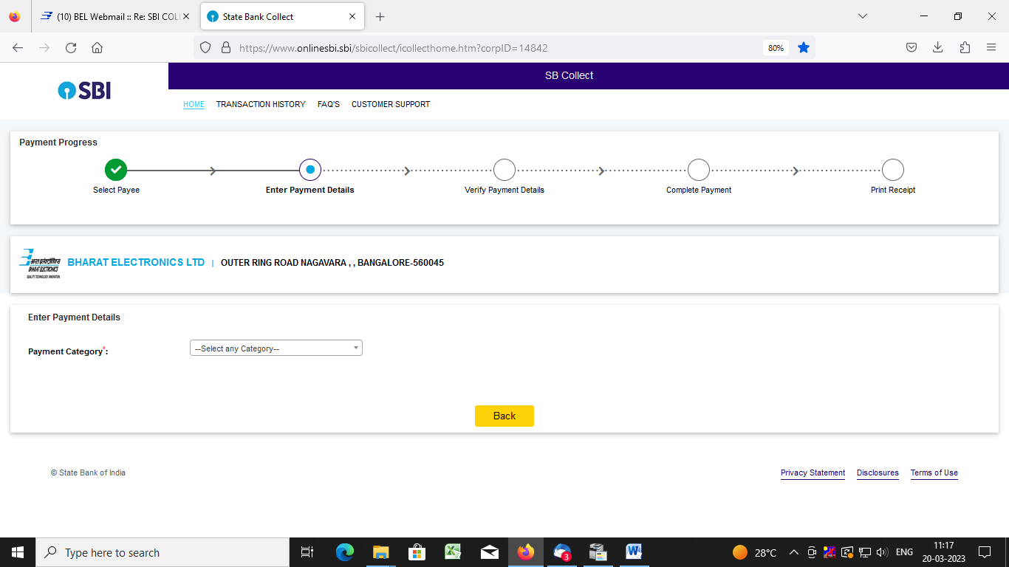

- Select payment category as applicable and choose [suitable post]/ Post applied for:

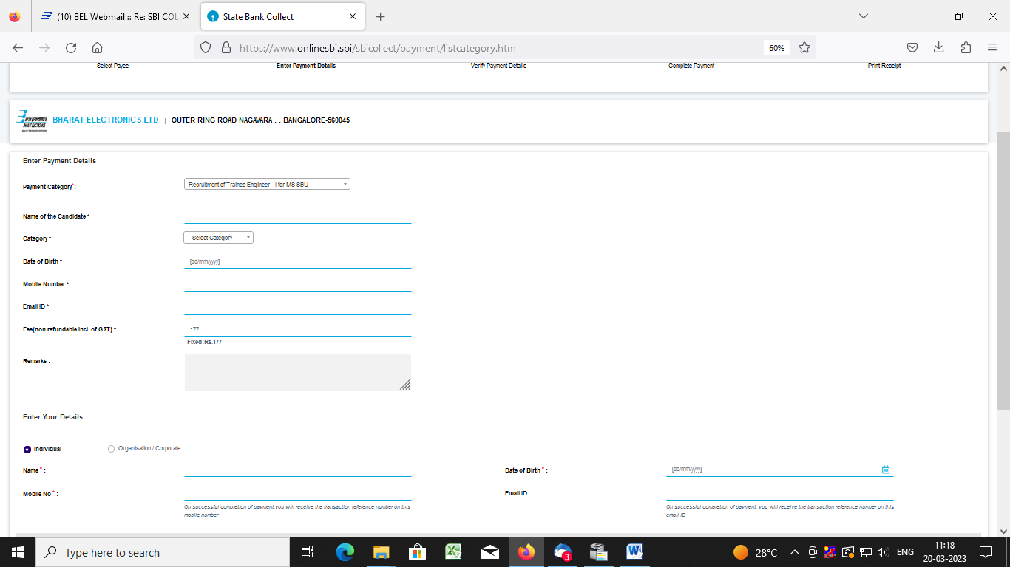

- Fill the details and click on submit button. (fields with * mark are to be Compulsorily filled & Applicable fee remitted.)

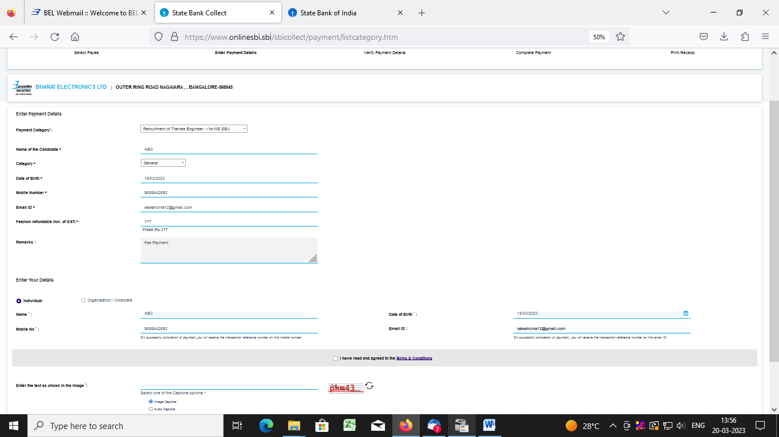

- Check the details and press the confirm button.

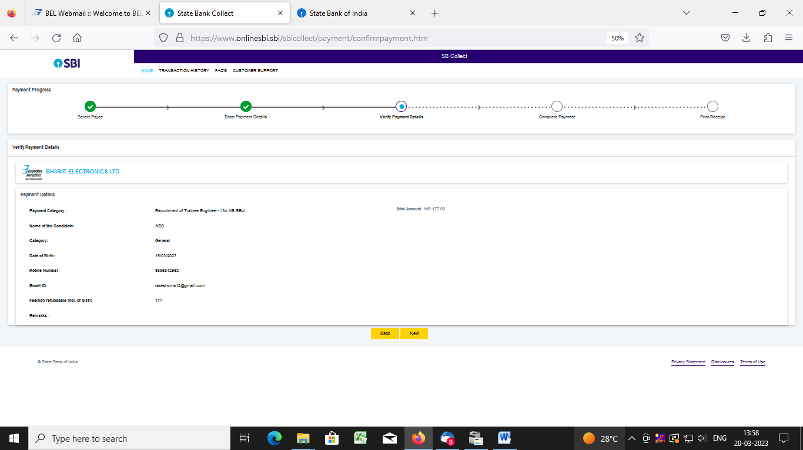

- Select any one of the mode of payments, i.e. "Net Banking" or "Card Payments" or "Other Payment Modes" as applicable and then proceed for making the fee payment. Download the receipt after successful completion of the payment.

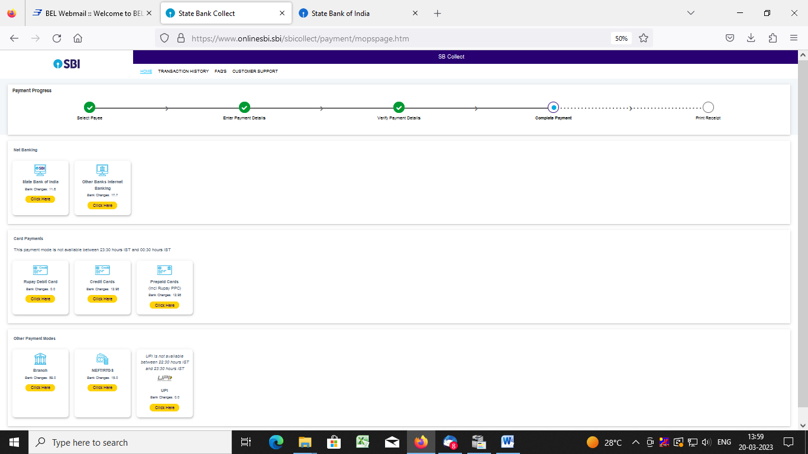

- In case, candidate opts "SBI Branch" as payment mode, candidate is required to download the pre-printed challan and deposit the fee amount (including applicable bank commission) in any of the SBI Branches andobtain seal and signature of the bank official on the challan (depositor copy) before leaving the bankcounter.
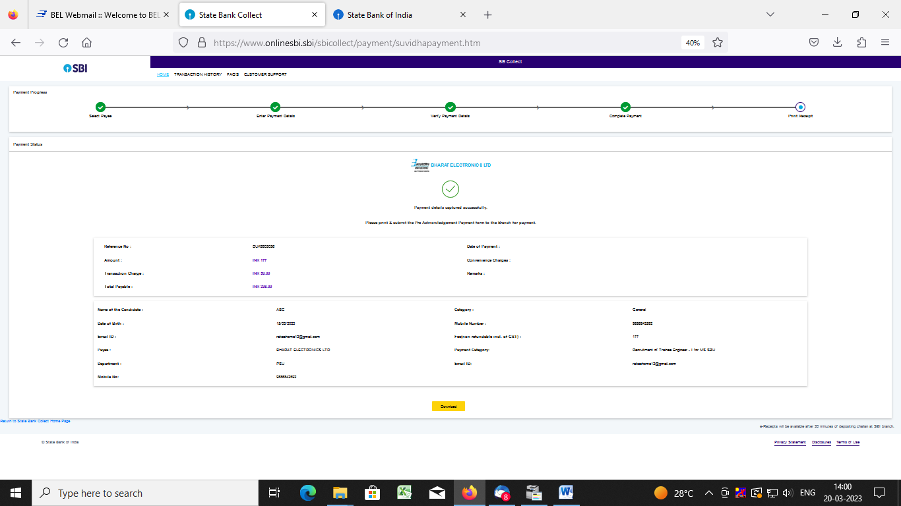

- SAMPLE COPY OF THE PRE-PRINTED CHALLAN. Example-
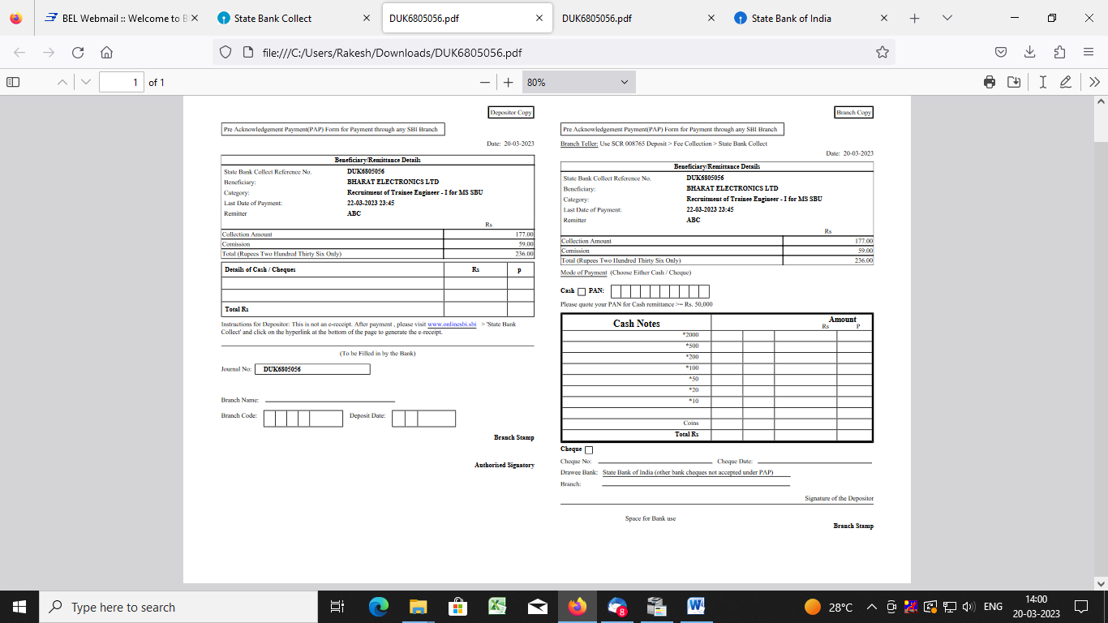

(Note: SB Collect Reference Number (sample number shown in above) generated after successful completion of payment has to be entered by the candidate in online application form in Bank Referencefield).

- MAKING FEES PAYMENT DIRECTLY BY LOGGING ON TO WWW.ONLINESBI.SBI

- Go to www.onlinesbi.sbi and select: - State Bank Collect.

- Select type of Corporation/Institution: - PSU - Public Sector Undertaking and press =>Go.

- Select PSU - Public Sector Undertaking: - Bharat Electronics Limited and press Submit.

- Select payment category: - and suitable post applied for.

- Complete the payment as explained above.

- WHILE MAKING THE PAYMENT, PLEASE DO NOT USE BACK BUTTON (i.e. ←) AT THE BROWSER UNLESS SPECIFICALLY ALLOWED AT ONLINESBI. IN CASE BACK BUTTON IS OPERATED,CANDIDATE HAS TO COMPLETE THE PAYMENT AS MENTIONED IN "B" ABOVE. 2

